**Migration Approach for OPMS Database:**

Migration of OPMS database from MS Access to MSSQL server is done using a Migration tool named **SSMA**(SQL Server Migration Assistant (SSMA) is a free supported tool from Microsoft that simplifies database migration process from Access to SQL Server and Azure SQL DB. SSMA for Access automates conversion of Microsoft Access database objects to SQL Server and Azure SQL DB database objects, loads the objects into SQL Server and Azure SQL DB, and then migrates data from Microsoft Access to SQL Server and Azure SQL DB.   
SSMA 7.3 for Access is designed to support migration from Microsoft Access 97 and higher to all editions of SQL Server 2012, SQL Server 2014, SQL Server 2016 and Azure SQL DB.)

Please find the below Steps for Migration.

**Step1:**

Go to Start and Run the SSMV7.3 using 32 bit version.

[C:\ProgramData\Microsoft\Windows\Start Menu\Programs\Microsoft SQL Server Migration Assistant for Access](C:\\ProgramData\\Microsoft\\Windows\\Start Menu\\Programs\\Microsoft SQL Server Migration Assistant for Access)

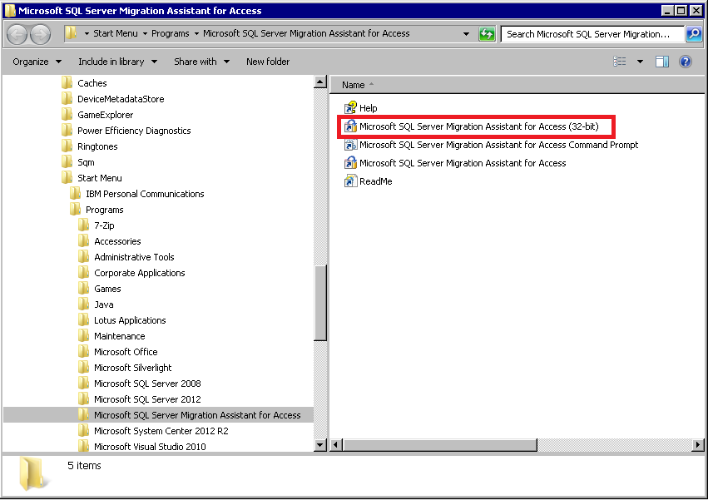

**Step2:**

Go to Migration Wizard and click Next

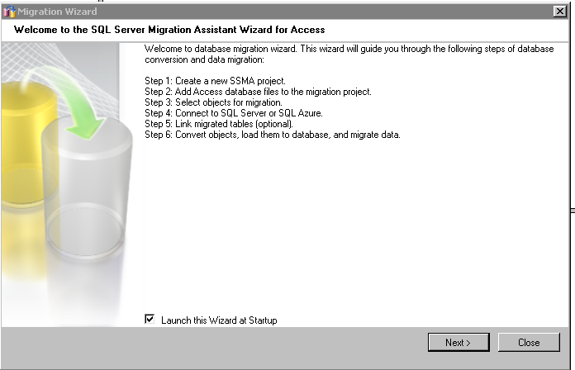

**Step3:**

Provide the Project name and file path to save the file, also select the version of MSSQL server.

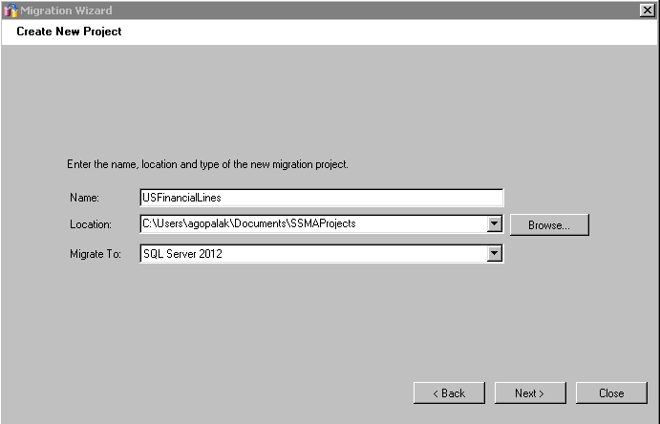

**Step4:**

Find the MS Access database by clicking on Add Database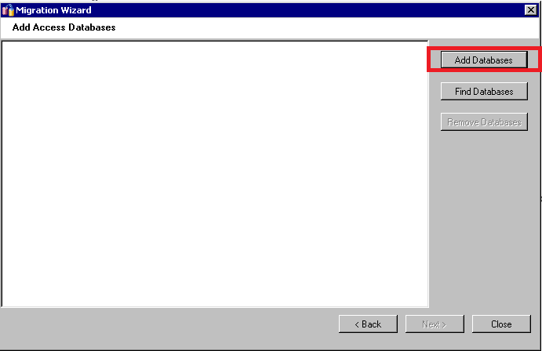

**Step5:**

Select the Objects to be migrated from the MS Access database.

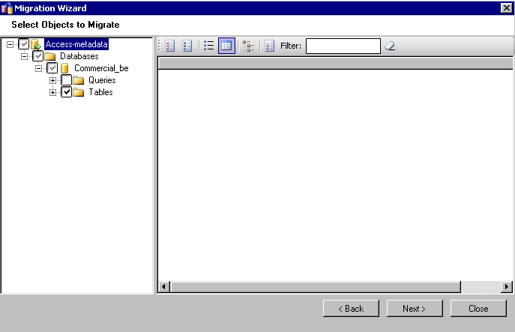

**Step6:**

Provide the SQL Server Name and Login Credentials to access the MSSQL server database and click Next.

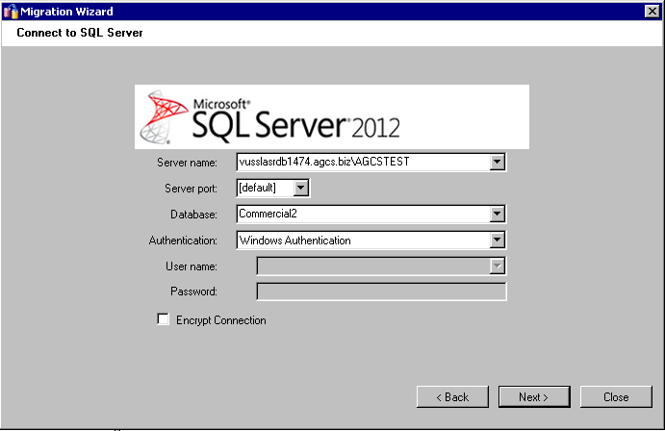

**Step7:**

To Link the MS SQL server data instead of MS Access data. Click on the Link tables and proceed Next.

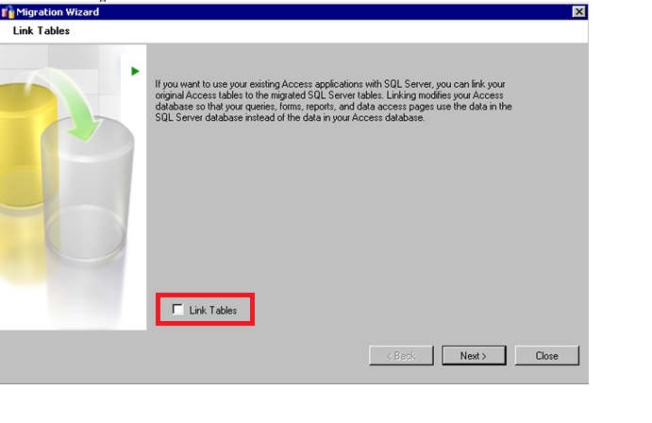

**Step8:**

Migrate the data in MS SQL server below is the conversion screen.

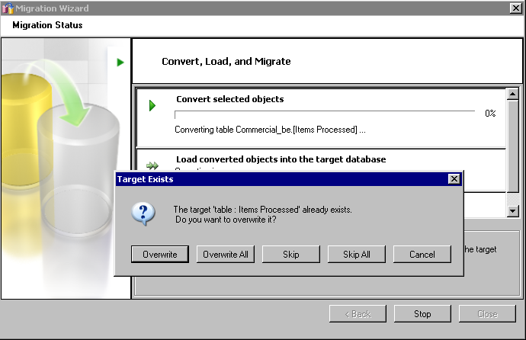

**Note :** Once the data is migrated to SQL Server, it’s recommended to create the Primary key on SQL Tables.

Some Changes has to be done in the front end after the migration Process due the changes in SQL data.

1) DAO updatable Recordsets

Search all VBA code for .add/.edit/.delete locations where DAO record sets are opened for editing and add the needed option "dbSeeChanges").

For example change

Set rst = db.OpenRecordset("Items Processed", dbOpenDynaset, dbAppendOnly)

to

Set rst = db.OpenRecordset("Items Processed", dbOpenDynaset, dbAppendOnly +, dbSeeChanges)

2) Boolean: -1 = True in MS Access, 1 = True in SQL Server

Search all VBA code and queries for "-1" and change to "True" where appropriate.

3) INT used to remove 'time" from Date/Time fields.

In MS Access, the INT function will remove the 'time' aspect for a Date/Time field, but this will result in an error in MS Access

Search all VBA code and queries for "INT" and replace with DATEVALUE where appropriate.

4) Add inheritable properties to the linked tables

Columns on MS Access tables can have properties that columns on SQL Server tables cannot. All of the properties of a table column in MS Access are inheritable. For example, the [User Name] column on the [Items Processed] table in the Commercial database has this property:



I have built a process to add these back. All that is required is to populate a table with the necessary properties. For example to add this property, the table would look like:



5) Date column has to be replaced in MS Access Forms & Queries.

For Example : Code like “Between Fromdate and Todate” should be replaced with

>= Datevalue(Fromdate) and < DateAdd(“d”,1,Datevalue(Todate))